# APPENDIX 4: SOFTWARE METHODS FOR CREATING LONG PROFILE GRAPHS OF TERRACE ELEVATIONS IN ARCGIS

METHOD: Creating Long Profile Graphs with Terrace Elevations and River Mean Surface Elevations

**Figure S31**

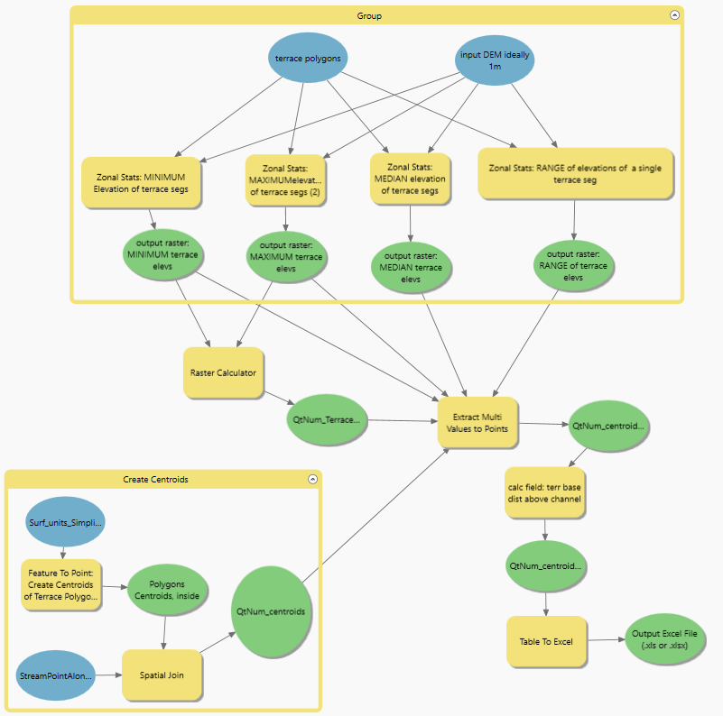

Basic Steps: In ArcGIS Pro 3.3.0

Start with a feature class of the terrace polygons

Feature to Point of Polygons – this is the centroids of the polygons

Creates a point representing the centroid of the polygon

Check the “INSIDE” option otherwise the centroid will be outside the polygon, which will cause problems later on

Add Spatial Join, type CLOSEST,

between the Stream Point Elevations and the terrace polygon centroids

Include a DISTANCE field as well call it “dist to river”

Export Features – export the spatial join as a new feature class

Keep track of where you save it, you may need it later

This step happens automatically as part of the spatial join operation in some newer versions of ArcGIS Pro

Zonal Statistics, MEDIAN, on the terrace polygons

Inputs: the DEM and the terrace polygons

Input feature zone data = terrace polygons features class

Zone field = OBJECTID

because we want stats for each segment of each terrace

Input value raster = your DEM of choice

Makes a raster with each non-null area the median elevation of the terrace polygon segment

Use this if you have low confidence that your terrace base elevations are consistent within the unit, or as an approximation of the upstream terrace base elevation

Zonal Statistics, MINIMUM, on the terrace polygons

Inputs: the DEM and the terrace polygons

Input feature zone data = terrace polygons features class

Zone field = OBJECTID

because we want stats for each segment of each terrace

Input value raster = your DEM of choice

Makes a raster with each non-null area the minimum elevation of the terrace polygon segment

Use this if you have high confidence that your terrace base elevations are consistent within the unit, or as an approximation of the downstream terrace base elevation\

Extract Multi Values To Points – on centroids, extract from both/all Zonal Stats rasters

Modifies the centroid feature point class, so maybe make a copy of it first…

Table to Excel – export features to an excel file

which you will use to make the long profile graph